Name: _______________________________

**Year 7 Biology**

**End of Topic Test**

/52

**Multiple Choice**

Please circle the correct answer on table below

|  |  |  |  |  |
| --- | --- | --- | --- | --- |
|  |  |  |  |  |
| **1.** | **A** | **B** | **C** | **D** |
| **2.** | **A** | **B** | **C** | **D** |
| **3.** | **A** | **B** | **C** | **D** |
| **4.** | **A** | **B** | **C** | **D** |
| **5.** | **A** | **B** | **C** | **D** |
| **6.** | **A** | **B** | **C** | **D** |
| **7.** | **A** | **B** | **C** | **D** |
| **8.** | **A** | **B** | **C** | **D** |
| **9.** | **A** | **B** | **C** | **D** |
| **10.** | **A** | **B** | **C** | **D** |
| **11.** | **A** | **B** | **C** | **D** |
| **12.** | **A** | **B** | **C** | **D** |
| **13.** | **A** | **B** | **C** | **D** |
| **14.** | **A** | **B** | **C** | **D** |
| **15.** | **A** | **B** | **C** | **D** |
| **16.** | **A** | **B** | **C** | **D** |
| **17.** | **A** | **B** | **C** | **D** |

1. State the type of scientist who names and classifies things.

A Ecologist

B Biologist

C Taxonomist

D Zoologist

2. Some plants are known as weeds. Describe a weed.

A A plant that does not grow very well

B A plant that grows where it is not wanted

C A plant that grows out of control

D A plant that does not produce flowers

3. Identify the characteristic that would be suitable for use in a strong key to identify dogs.

A The loudness of their bark

B The presence of a patch of different coloured fur around their eye

C Whether they were short-haired or long-haired

D The size of their paws

4. Identify which of the following statements about the levels of classification is true.

A There are more different types of organisms in a class compared to a genus.

B Phylum is a group within a family.

C There are many classes within an order.

D The organisms within a kingdom are most like each other.

5. Select the best description of the term binomial nomenclature.

A A system or scientific naming that was used in the past but is no longer used.

B Using only two names to identify any living thing.

C A system of naming that does not change.

D A shorthand version of the name of an organism.

6. Select the plants from this group that are most closely related:

*Hakea sericea Grevillea sericea*

*Hakea pachyphylla Acacia pachyphylla*

A *Hakea sericea, Grevillea sericea*

B *Acacia pachyphylla, Hakea pachyphylla*

C *Hakea sericea, Hakea pachyphylla*

D *Grevillea sericea, Acacia pachyphylla*

7. Read the four statements below, then deduce which pair of organisms are most alike.

* A and B belong to the same Genus.
* A and C belong to the same Order.
* C and B belong to the same Family.
* They all belong to the same Kingdom as D.

A A and B

B A and C

C C and B

D C and D

8. Identify the phylum this animal belongs to.

*It lives in water. It filters its food out of the water that passes through the pores in its body. Wastes and water are pushed out through a hole in the top of its body.*

A Cnidarian

B Annelid

C Nematode

D Poriferan

9. Identify the phylum this animal belongs to.

*It lives in water or very moist places. It is bilaterally symmetrical with a body flattened from top to bottom. Many are scavengers in the ocean.*

A Poriferan

B Nematode

C Echinoderm

D Platyhelminth

10 Identify the class this fish belongs to.

*It has a skeleton made of cartilage and a fully functioning jaw*

A Aves

B Condrichthyes

C Ostiechthyes

D Agnatha

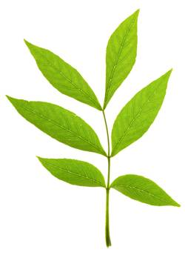11. Use the following key to identify the leaf shown below.

1a Leaf blade divided into many parts (leaflets) 4

b Leaf blade entire (not divided) 2

2a Leaf shaped like a hand with fingers spread Maple

b Leaf not hand-shaped 3

3a Leaf margin (edge) has small teeth Rose

b Leaf margin is lobed Oak

4a Leaflets organised like fingers on a hand Chestnut

b Leaflets on either side of main vein Ash

A Chestnut

B Rose

C Ash

D Maple12. Use the following key to identify the correct description of an oak leaf.

1a Leaf blade divided into many parts (leaflets) 4

b Leaf blade entire (not divided) 2

2a Leaf shaped like a hand with fingers spread Maple

b Leaf not hand-shaped 3

3a Leaf margin (edge) has small teeth Rose

b Leaf margin is lobed Oak

4a Leaflets organised like fingers on a hand Chestnut

b Leaflets on either side of main vein Ash

A Leaf divided into many leaflets with lobed edges.

B Leaf with an entire blade that is lobed at the edges. Not shaped like a hand.

C Leaf with an entire blade with the veins looking like the five fingers of a hand.

D Leaf divided into leaflets organised like a hand.

13. Propose the phylum to which the organism in the picture belongs.

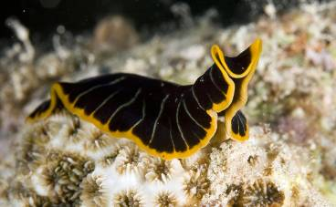

A Platyhelminth

B Nematode

C Annelid

D Mollusc

14. Use the following key to identify leaves A and B.

1a Leaf blade divided into many parts (leaflets) 4

b Leaf blade entire (not divided) 2

2a Leaf shaped like a hand with fingers spread Maple

b Leaf not hand-shaped 3

3a Leaf margin (edge) has small teeth Rose

b Leaf margin is lobed Oak

4a Leaflets organised like fingers on a hand Chestnut

b Leaflets on either side of main vein Ash

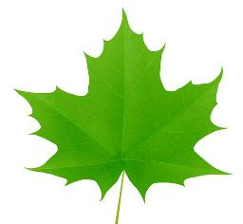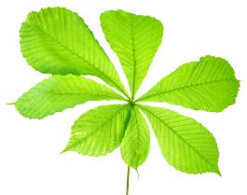Leaf A Leaf B

A A–Rose, B–Maple

B A–Chestnut, B–Maple

C A–Oak, B–Chestnut

D A–Maple, B–Rose

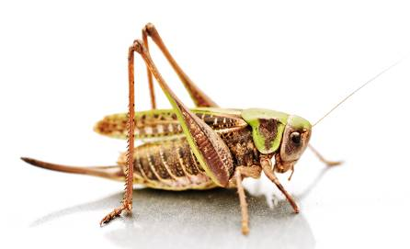15. Both these animals belong to the Arthropod phylum. Propose the characteristic that is not typical of all members of this phylum.

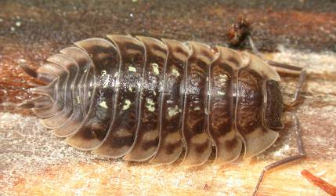

A The presence of jointed legs

B Having segmented bodies

C Having an exoskeleton

D Having a pair of long antennae

16. An animal with an exoskeleton must moult before it can grow. This means that the animal gets rid of its old, small exoskeleton and forms a new and larger one. Moulting happens when the casing or shell cracks open and drops off. A new, larger exoskeleton then forms. It starts soft but then hardens to form a new shell or casing for the animal.

Empty and dried shell-like casings of cicadas are often found on trees. Identify which of the following best describes these casings:

A The casings are the old exoskeletons of cicadas that were moulted when the cicadas grew.

B The cicadas are growing within these casings but are currently too small to see.

C The casings are the eggs of new cicadas.

D The casings are the remains of dead cicadas.

17. Chordates have a skeleton inside their bodies. This type of skeleton is known as an endoskeleton. An exoskeleton is very different. An exoskeleton is a hard, external skeleton that forms a shell or casing around the animal, its body, head, tail and legs. Arthropods have an exoskeleton.

Identify which of the following is the best meaning for the prefixes endo and exo when discussing skeletons:

A endo and exo both mean the same thing.

B endo means external, exo means internal.

C endo means internal, exo means external.

D endo means that an animal has a skeleton, exo means that an animal has none.

**Short Answer**

1. Explain the following observation. Mushrooms grow well under the house, whereas grass growing there turns yellow and dies. (2)

______________________________________________________________________________________________________________________________________________________________________________________________________________________________________________________

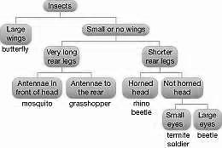2. Using the dichotomous key provided, describe the characteristics of: (3)

a a mosquito

b a grasshopper

c a termite soldier

a a mosquito

____________________________________________________________________________________________________________________________________________________________________

__________________________________________________________________________________

b a grasshopper

______________________________________________________________________________________________________________________________________________________________________________________________________________________________________________________

c a termite soldier

______________________________________________________________________________________________________________________________________________________________________________________________________________________________________________________

3. Below is a list of vehicles. Construct a key (branch diagram) that would allow someone who was unfamiliar with them to identify them. (5)

bicycle, tricycle, helicopter, train, bus, car, motorbike, sailboat, motorboat

4. Use the classification key provided to help you classify the following organisms. For each invertebrate, write down the features listed as you progress through the key. (4)

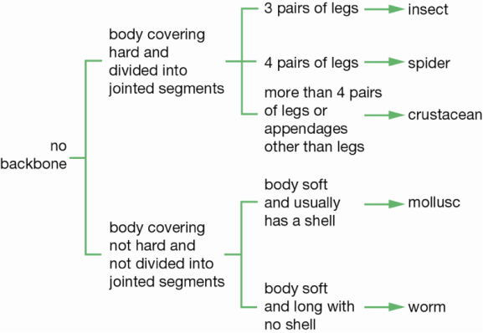

a Snail

__________________________________________________________________________________

__________________________________________________________________________________

__________________________________________________________________________________

b Garden worm

__________________________________________________________________________________

__________________________________________________________________________________

__________________________________________________________________________________

c Huntsman

__________________________________________________________________________________

__________________________________________________________________________________

__________________________________________________________________________________

d Butterfly

__________________________________________________________________________________

__________________________________________________________________________________

__________________________________________________________________________________

5. Read the four descriptions of chordates. (4)

Animal 1: four legs, body covering of scales, ectothermic

Animal 2: body covering of hair, endothermic, some lay eggs

Animal 3: body covering of scales, fins, lives in water

Animal 4: body covering of feathers, endothermic, scales on legs

Propose the animal that belongs to each group.

Mammal = Animal # ________

Bird = Animal # ________

Reptile = Animal # ________

Fish = Animal # ________

6. Put the following list of classification levels in order from the largest to the smallest group. (2)

class, family, genus, kingdom, order, phylum, species

__________________________________________________________________________________

__________________________________________________________________________________

7. Match each term below with the correct definition by writing the correct roman numeral

a Monera = __________ (5)

b Protist = ____________

c Fungi = ______________

d Plant = ___________

e Animal = ____________

i Microscopic single-celled organisms with a distinct nucleus.

ii Multicellular organisms with a distinct nucleus but without cell walls. Lack chlorophyll.

iii Microscopic single-celled organisms without a distinct nucleus.

iv Multicellular organisms with cell walls and a distinct nucleus. Lack chlorophyll.

v Multicellular organisms with cell walls and a distinct nucleus. Some cells contain chlorophyll.

8a Name the three groups of mammals. (3)

__________________________________________________________________________________

__________________________________________________________________________________

b Describe the differences that cause mammals to be separated into these three groups. (3)

9.a From the information below, select the two animals that are most closely related. (1)

**Animal 1**

Kingdom: Animal

Phylum: Chordate

Class: Mammal

Order: Carnivore

Family: Felidae

Genus: Panthera

Species: Panthera leo

**Animal 2**

Kingdom: Animal

Phylum: Chordate

Class: Mammal

Order: Diprotodontia

Family: Vombatidae

Genus: Vombatus

Species: Vombatus ursinus

**Animal 3**

Kingdom: Animal

Phylum: Chordate

Class: Sauropsida

Order: Testudines

Family: Testudinidae

Genus: Geochelone

Species: Geochelone gigantea

**Animal 4**

Kingdom: Animal

Phylum: Chordate

Class: Mammal

Order: Diprotodontia

Family: Macropodidae

Genus: Macropus

Species: Macropus giganteus

a Animal number _____ and animal number _____ (1)

b Explain your decision. (2)